SHOCK ABSORBER DESIGN AND ANALYSIS REPORT

Prepared By
Vaishnav S

Institution
RIT Kottayam

Abstract
This project presents the design and finite element analysis of a shock absorber using SolidWorks and ANSYS Workbench. Static structural, modal, and random vibration analyses were conducted to evaluate deformation, natural frequencies, and vibration response characteristics of the assembly.

Objectives
- Design a shock absorber assembly using SolidWorks.
- Perform finite element analysis using ANSYS Workbench.
- Evaluate structural deformation.
- Determine natural frequencies through modal analysis.
- Study vibration response under PSD excitation.

Software Used
- SolidWorks
- ANSYS Workbench 2026 R1 Student Version

CAD Model
The shock absorber assembly was created in SolidWorks and exported to ANSYS for simulation studies.

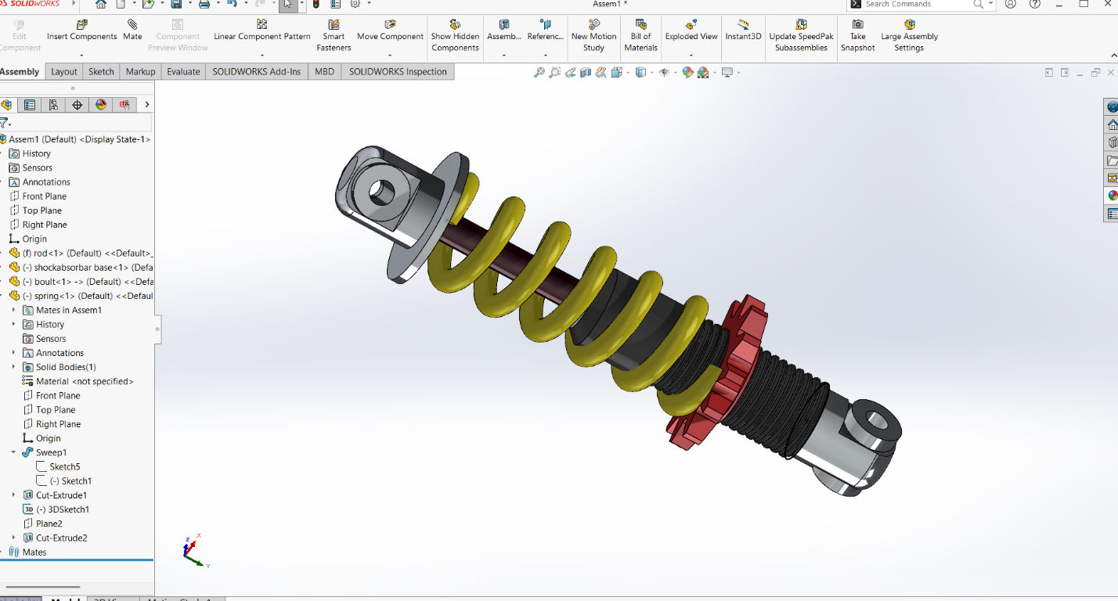

Mesh Generation
A finite element mesh was generated to discretize the geometry for numerical analysis.
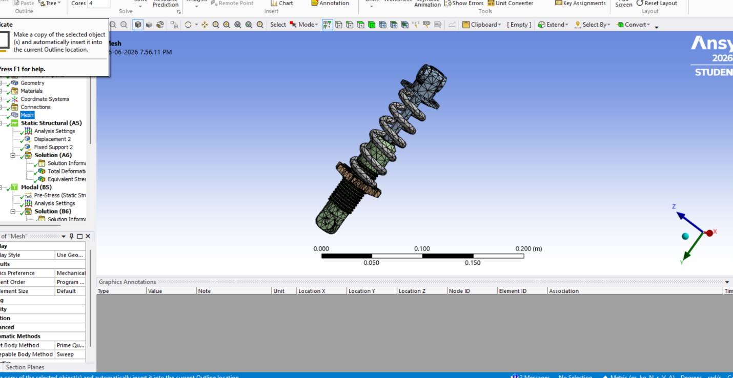

Static Structural Analysis

Boundary Conditions
- Fixed Support applied at one end.
- Displacement applied at the opposite end.

Results
Maximum Total Deformation:
0.0010009 m (1.0009 mm)

Modal Analysis
The natural frequencies obtained are:
Mode | Frequency (Hz)
1 | 618.78
2 | 625.92
3 | 873.09
4 | 900.35
5 | 1139.3
6 | 1226.7

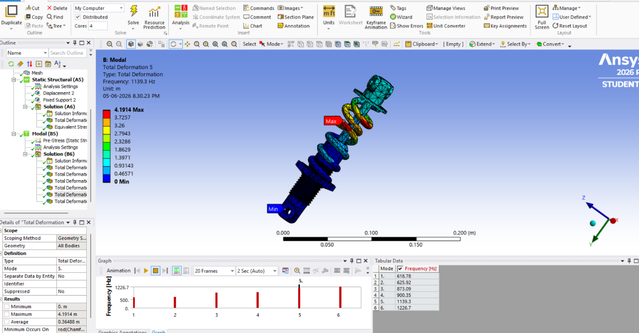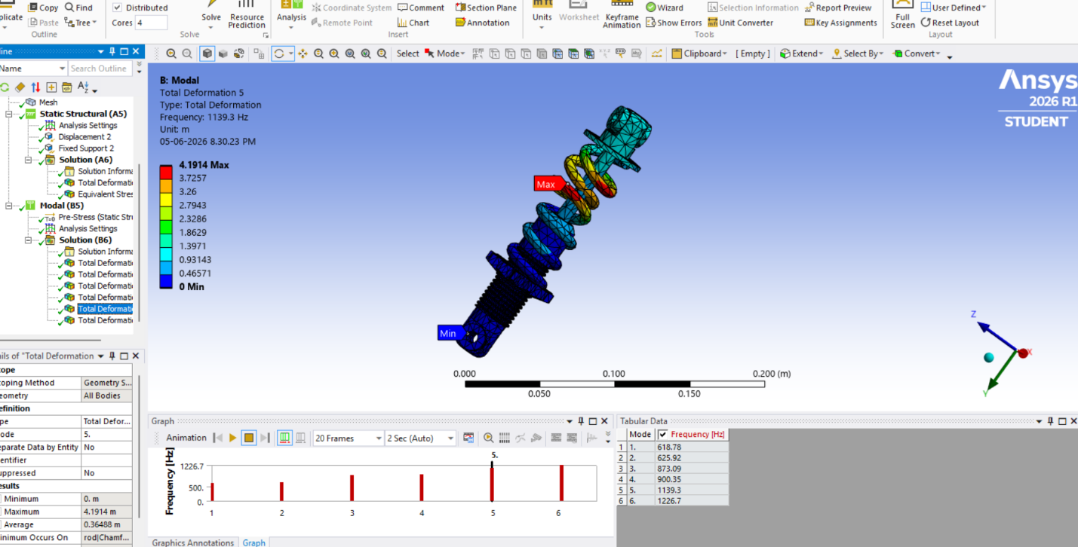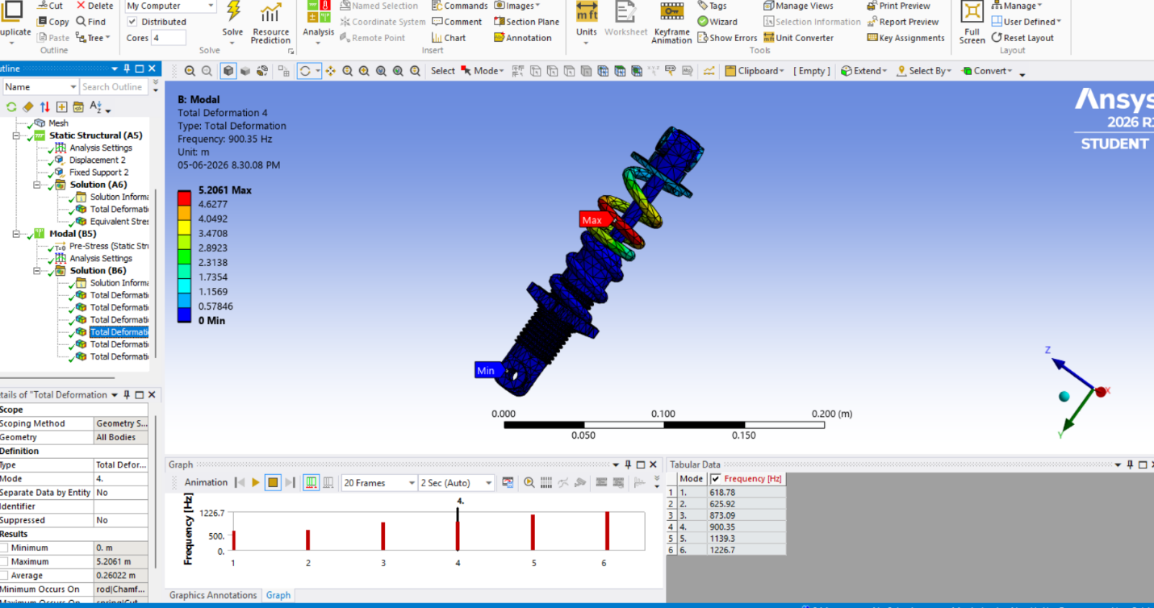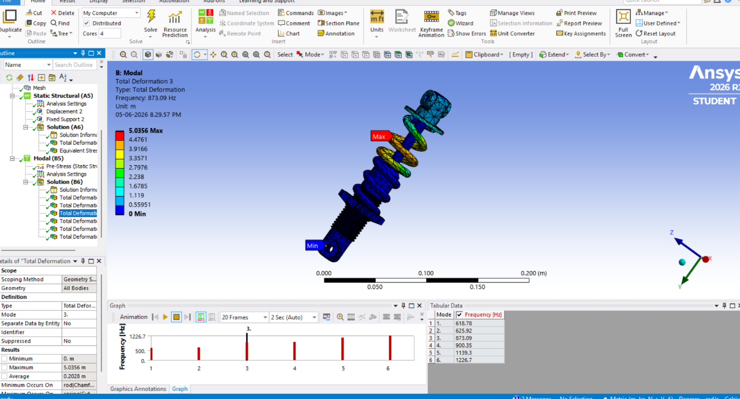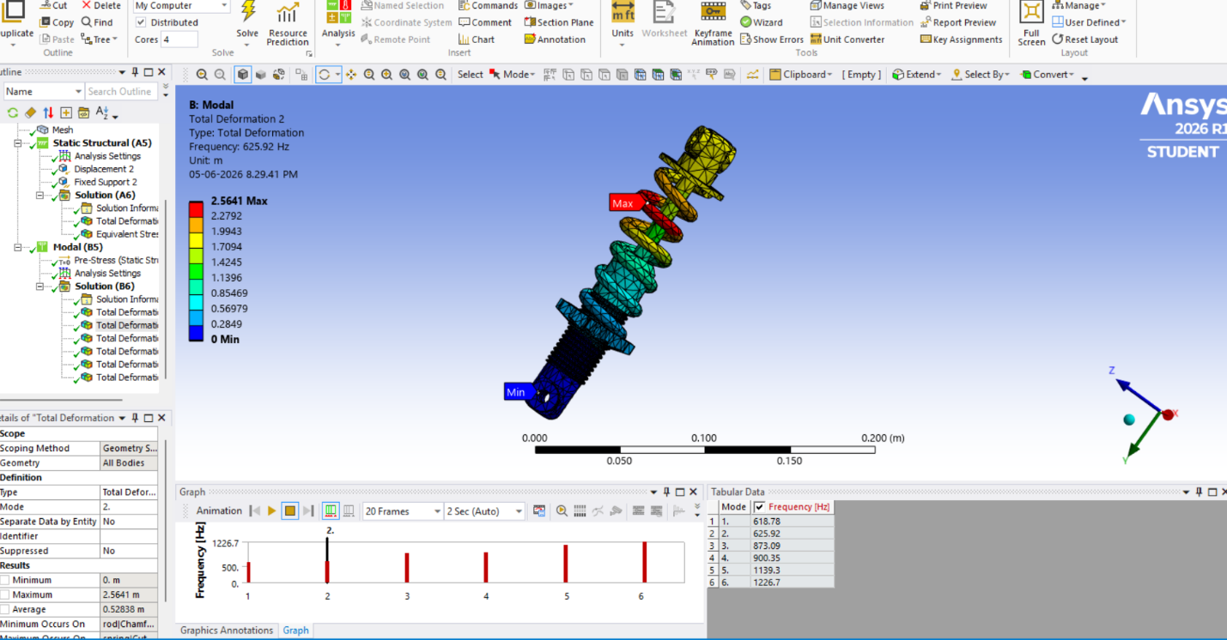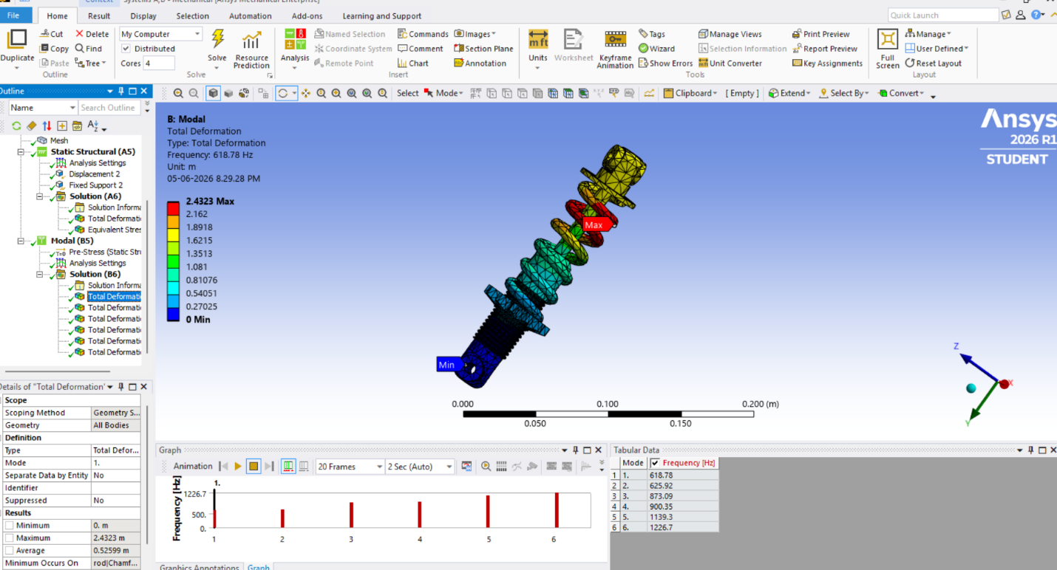

Random Vibration Analysis

PSD Input
Frequency (Hz) | PSD Acceleration
5 | 1.0E-4
10 | 1.5E-4
20 | 2.0E-4
30 | 2.0E-4
50 | 1.0E-4

Results

Equivalent Stress
Maximum Equivalent Stress:
1987 Pa

Directional Deformation
- X Direction: 4.0364E-10 m
- Y Direction: 3.2514E-9 m
- Z Direction: 5.1121E-10 m

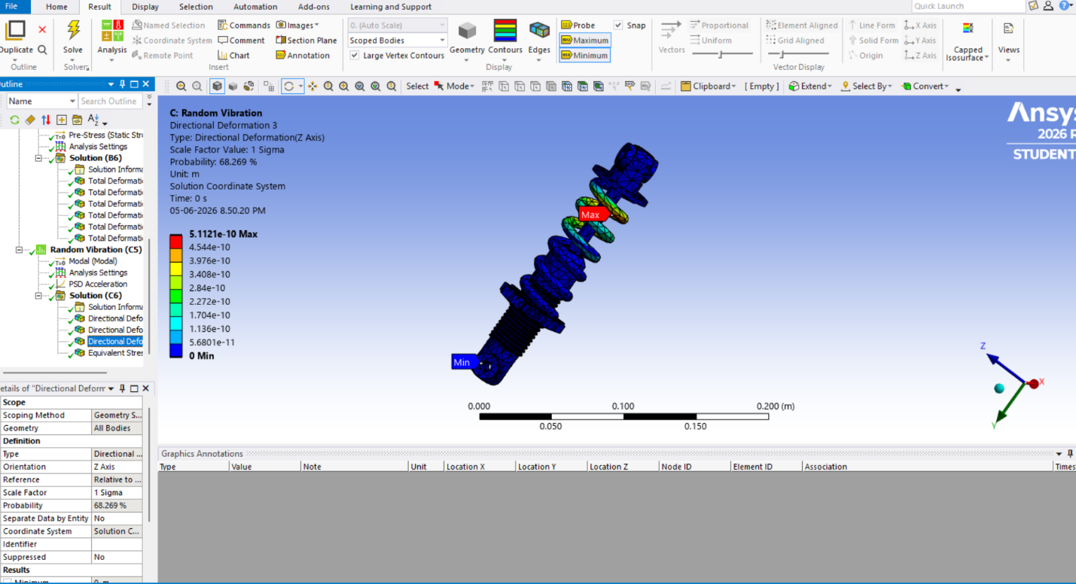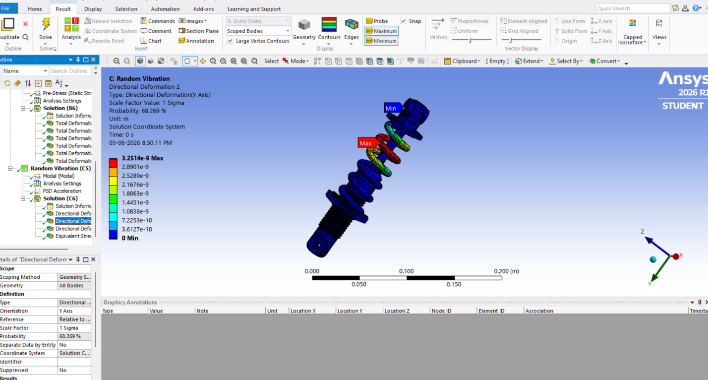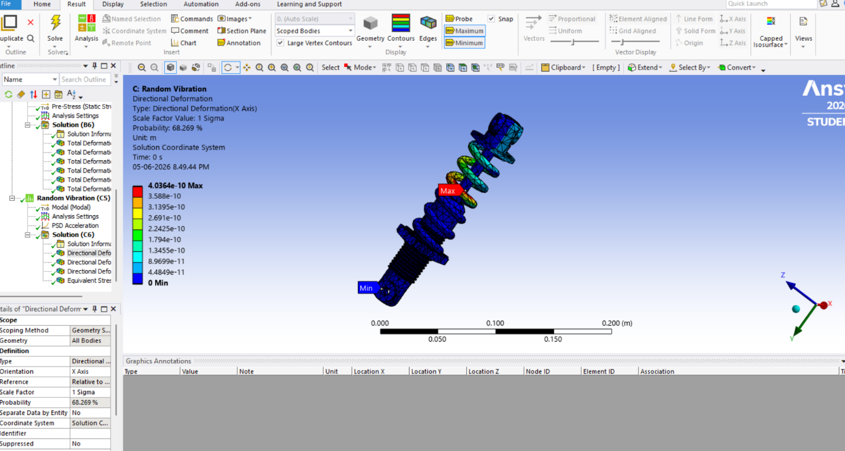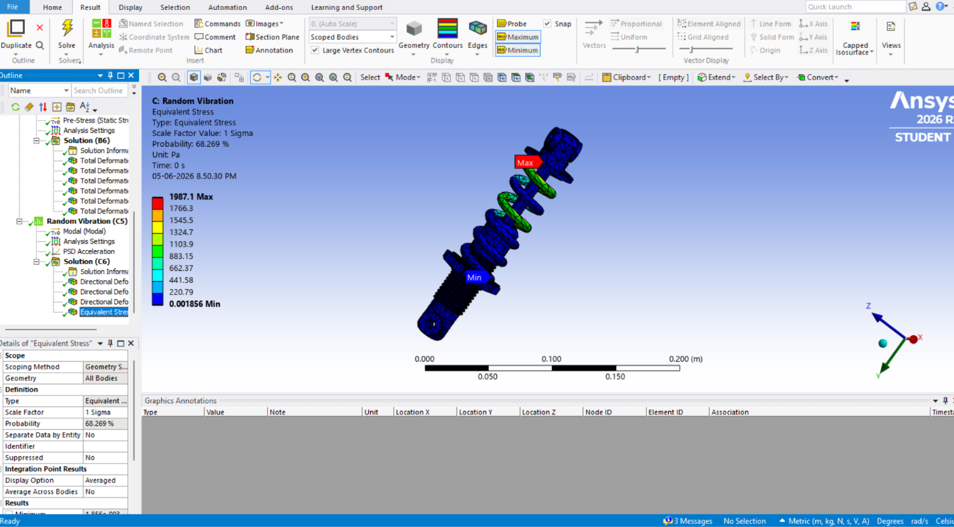

Conclusion
The shock absorber assembly was successfully designed and analyzed using SolidWorks and ANSYS Workbench. Static structural analysis evaluated deformation under loading conditions. Modal analysis identified six natural frequencies, while random vibration analysis assessed the dynamic response under PSD excitation. The project demonstrates the application of Finite Element Analysis (FEA) techniques in mechanical component design and validation.

References
- ANSYS Workbench Documentation
- SolidWorks Documentation
- Finite Element Analysis Fundamentals
- XYZ Engineering Tutorials, "Shock Absorber Analysis in ANSYS," YouTube, accessed June 2026.

